Big Data
Shaon Khan

1. What is Big Data?
Big Data means data that is too large, too fast, and too complex for old tools to handle. Traditional database tools cannot store, process, or analyze this kind of data easily.
The goal of Big Data is simple: get the right information, to the right person, at the right time, so that better decisions can be made. To work with Big Data, we need new, flexible, and scalable systems that can grow as data grows.

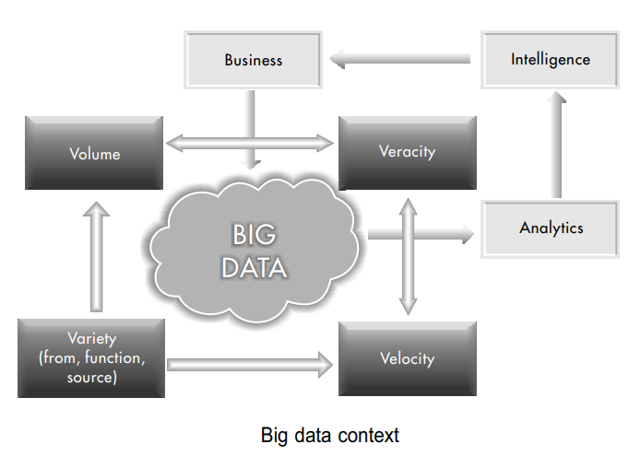
Figure 1: Big Data Context - how Volume, Velocity, Variety, and Veracity connect to Business Intelligence

2. The Four Vs of Big Data
Big Data is defined by four key properties, commonly called the four Vs. When all these arrive together, they create a very difficult problem to solve.

Volume - How Much Data
Volume means the size of the data. Traditional data is measured in Gigabytes (GB) or Terabytes (TB). But Big Data is measured in Petabytes (PB) and Exabytes (1 Exabyte = 1 million Terabytes).
Why is there so much data? The cost of storing data has dropped by 30 to 40 percent every year. So companies and devices now record almost everything. This is called the datafication of the world.

Velocity - How Fast Data Moves
Velocity means the speed at which new data is created and sent. If traditional data is like a lake, Big Data is like a fast-flowing river. Billions of devices generate and send data at the speed of light through the internet.
The main reason for this speed is faster internet. Home and office internet speeds are increasing from 10 MB/s to 1 GB/s, which is 100 times faster. You cannot control how fast data arrives.

Variety - How Many Types of Data
Variety means data comes in many different forms and from many sources. Think of it like the world's biggest shopping mall with unlimited choices.
- Form: numbers, text, graphs, maps, audio, video
- Function: conversations, songs, business records, machine performance logs, archived data
- Source: mobile apps, websites, search logs, IoT devices

Veracity - How Trustworthy the Data Is
Veracity means the quality and truthfulness of data. Big Data is messy. There is a lot of wrong information out there.
- Technical error: sensors and machines can malfunction and send wrong data
- Human error: people make mistakes when entering or sharing data
- Intentional error: some data is purposely wrong for competitive or security reasons
For example, information from whitehouse.gov or nytimes.com is more likely to be correct than from unknown websites. Even Wikipedia can have errors since anyone can edit it.

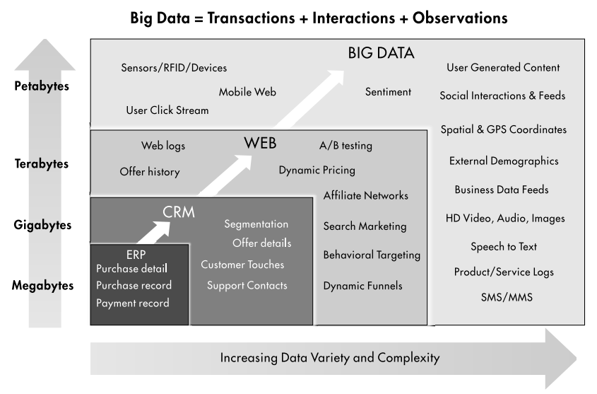
Figure 2: Big Data is made of Transactions + Interactions + Observations, growing from Megabytes to Petabytes

3. Sources of Big Data
Big Data comes from three main types of communication:
- People-to-People Communications: social media, messages, emails (e.g. Facebook, Twitter)
- People-to-Machine Communications: smart watches, IoT medical devices, web browsing, search
- Machine-to-Machine Communications: RFID tags, sensors, Internet of Things (IoT) devices

4. Big Data Architecture
A Big Data system has several layers that work together to collect, process, store, and serve data.

Data Ingest Layer
This is where data enters the system. It receives data from many different sources at different speeds and in different amounts.

Batch Processing Layer
This layer takes large amounts of stored data and processes it together using parallel programming techniques, such as MapReduce. It is useful when you do not need results instantly.

Stream Processing Layer
This layer processes data in real time as it arrives. It is used when you need instant results, like a live traffic update or fraud detection.

Data Organizing Layer
After processing, this layer organizes the data so it is easy to find and use.

Distributed File System Layer
This is the heart of Big Data. It stores huge amounts of data across many computers. The main technology used here is HDFS - Hadoop Distributed File System.

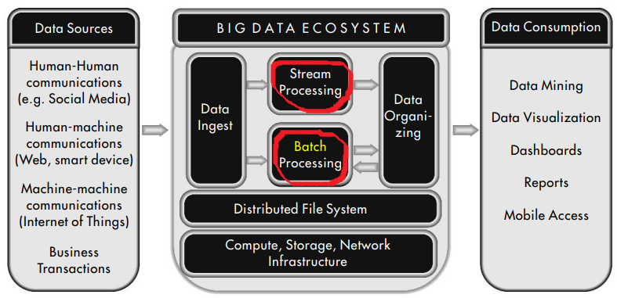
Figure 3: Big Data Ecosystem - from data sources through processing layers to data consumption

5. Technology Challenges and Solutions
Working with Big Data has four main challenges. Each challenge has a matching technology solution.
- Storing huge volumes of data without losing it - solved by HDFS
- Handling data streams coming in at very high speed - solved by Spark
- Managing many different forms and types of data - solved by HBase and Cassandra
- Processing data quickly using parallel techniques - solved by MapReduce

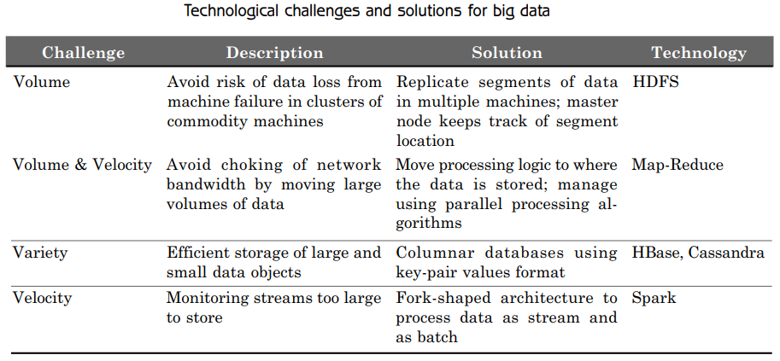
Figure 4: Technology Challenges and Solutions for Big Data

6. Big Data vs Traditional Data
Big Data is very different from traditional data in almost every way. The table below shows a quick comparison.

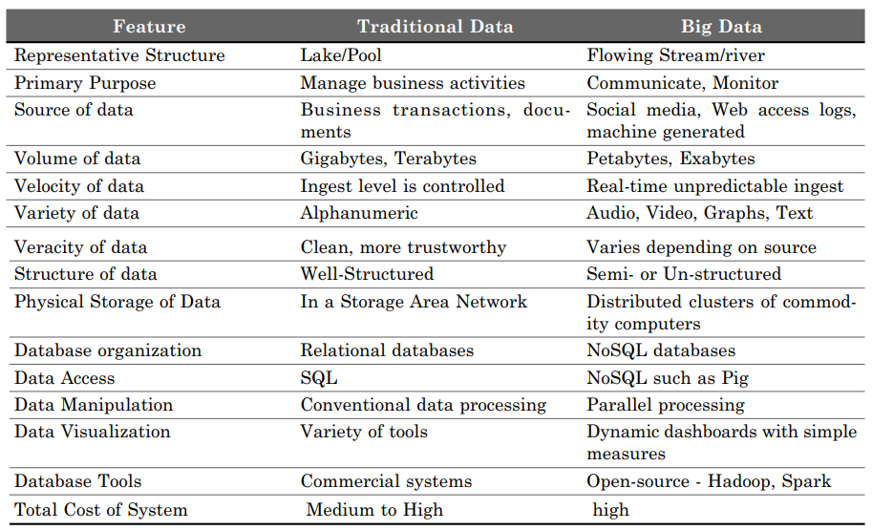
Figure 5: Comparison of Traditional Data and Big Data

7. Organizing and Analyzing Big Data
There are two main ways to work with Big Data:
- Real-time processing: Process data as it comes in. Good for quick decisions, like live dashboards or alerts.
- Batch processing: Store data first, then analyze it later. Good for finding long-term patterns and generating reports.

Real-Time Dashboard Example
The chart below shows a real-time dashboard for a website blog. It tracks views and visitors each month, making it easy to see when traffic goes up or down.

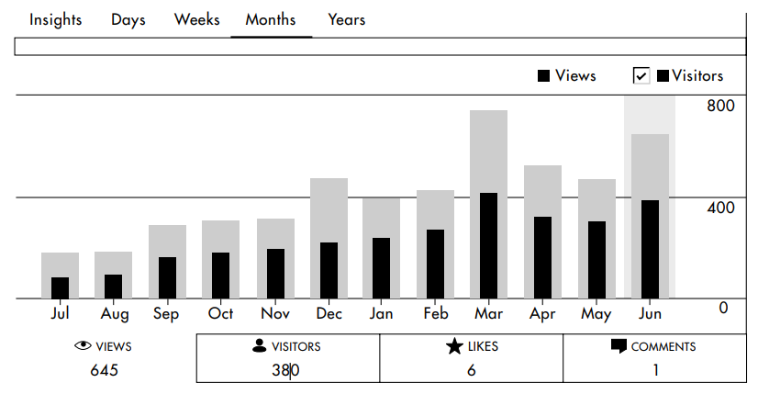
Figure 6: Real-time website performance dashboard showing monthly views and visitors

Word Cloud Example
Word clouds are another way to visualize Big Data. The image below shows the most common words used in Hillary Clinton and Donald Trump's tweets during the 2016 US election. Bigger words appear more often.

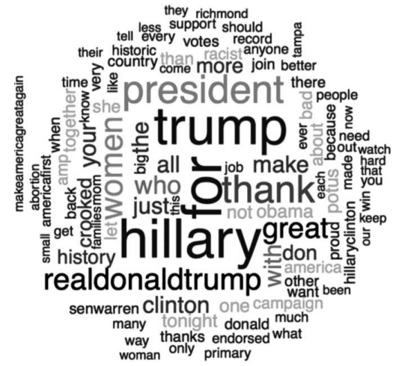
Figure 7: Word cloud of Hillary Clinton and Donald Trump tweets, 2016 US Election

8. Applications of Big Data

Monitoring and Tracking
- Vehicle tracking systems (GPS)
- Public health monitoring
- Consumer sentiment monitoring from social media
- Asset tracking, e.g. airplane black box
- Supply chain and electricity consumption monitoring
- Preventive machine maintenance

Analysis and Insight
- Predictive Policing: The Los Angeles Police Department used Big Data to predict where crimes might happen before they occur.
- Political Campaigns: US President Barack Obama was the first to use Big Data in elections in 2008. His campaign collected data from millions of supporters and used it to gather small donations from many people.
- Personal health monitoring and recommendations
- New product development based on customer data
- Flexible auto insurance based on driving behavior
- Location-based retail promotions and recommendation systems

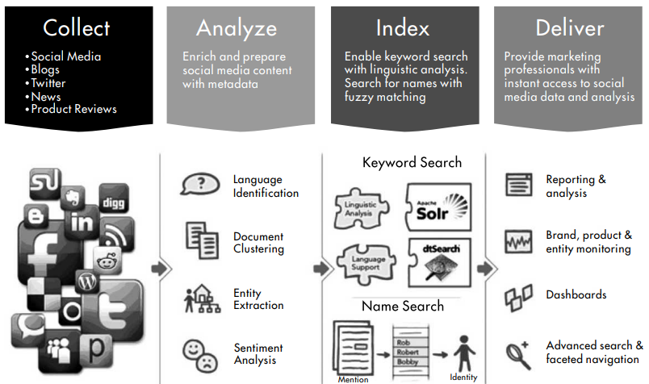
Figure 8: Google Query Architecture - Collect, Analyze, Index, and Deliver social media data

9. The Complete Big Data Ecosystem
The full Big Data system connects data sources on the left to data consumption on the right, through a processing engine in the middle.
- Data Sources: social media, web activity, smart devices, business transactions, IoT sensors
- Processing: stream processing (real-time) and batch processing (stored data)
- Distributed File System: stores all data securely across many machines
- Data Consumption: data mining, visualization, dashboards, reports, mobile access

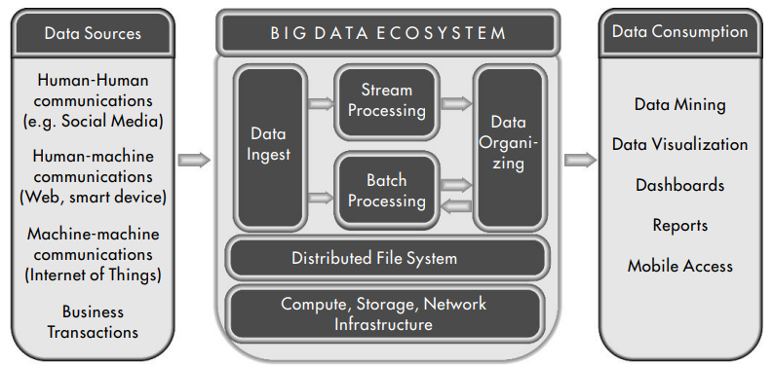
Figure 9: The full Big Data Ecosystem from sources to consumption

Summary
Big Data is not just large data. It is data that is large in volume, fast in velocity, diverse in variety, and uncertain in veracity. It needs special tools, architectures, and techniques to store, process, and use effectively.
The key technologies include HDFS for storage, MapReduce and Spark for processing, and NoSQL databases like HBase and Cassandra for flexible data management. Big Data is used in health, business, policing, elections, and many more fields.

